**Liljana Josevski**

**S3909588**

**GitHub Repo-**

**GitHub Pages-**

**Assignment 1**

**Personal Information**

Hi, my name is Liljana Josevski I am 33 years old, and I have been married to Jason for 12 years, we have three beautiful daughters, Milla, 9 years old, Eva, 7 years old and Eden, 4 years old. We also have a white English Staffy named JoJo and an auburn domestic cat named Simba. They are an unlikely pair but are best of friends. My student Number is s3909588 and student email is s3909588@student.rmit.edu.au.



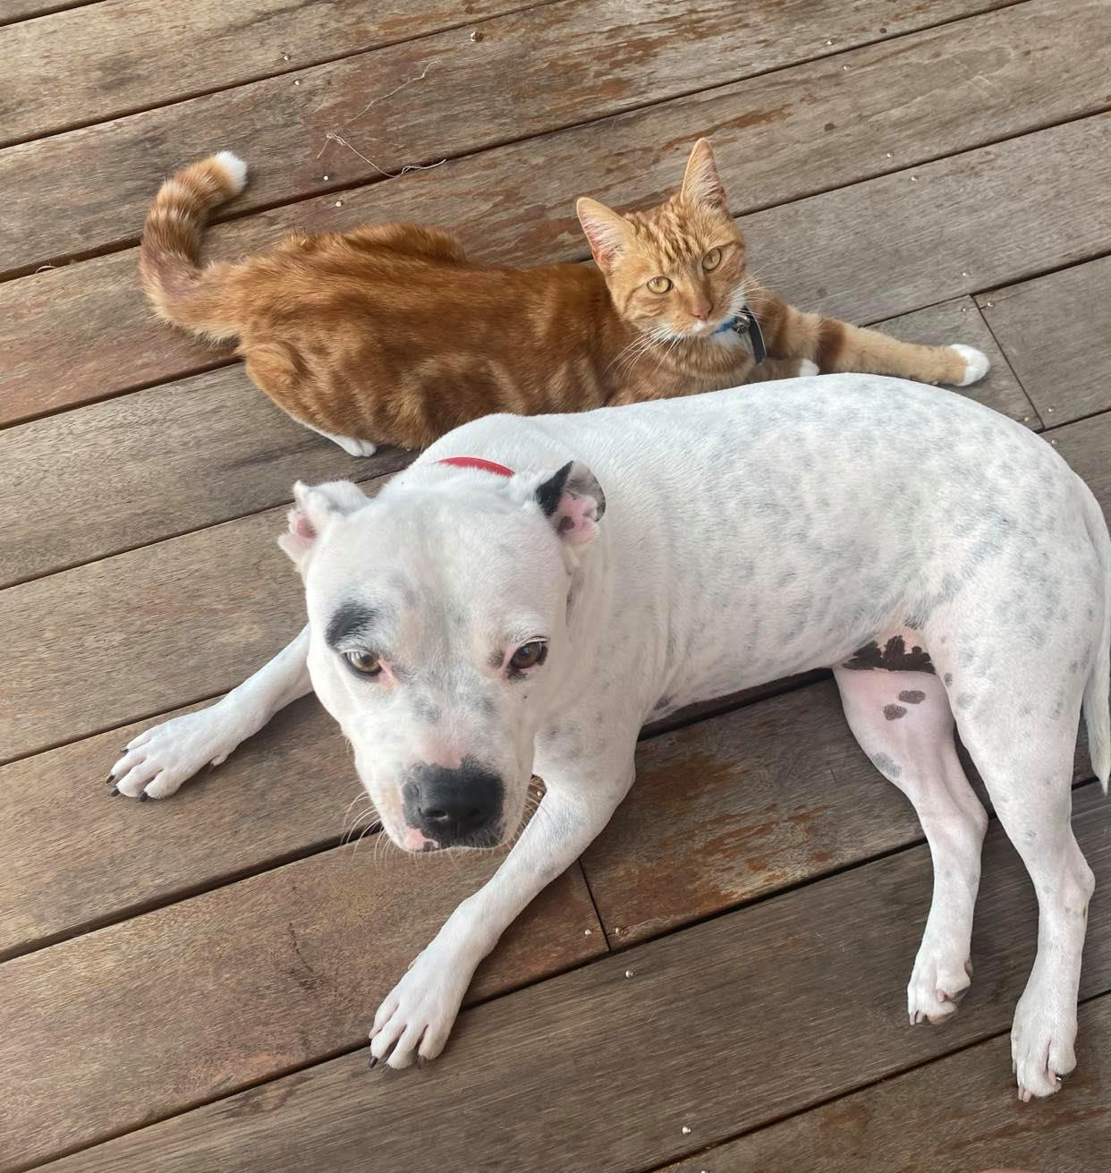

I have been a hairdresser for 14 years as hair dressing runs in my family, my mum was a hairdresser, my auntie, my sister and many of my cousins so, hairdressing came very naturally to me. I have come to a point in my life where I need to think about going back to work as all my kids will be in primary school as of next year. My husband has his own company and concentrates on managed services and server upgrades also does some contract work for Ambulance Victoria and the state government. I want to become experienced and confident in the IT field so I could be able to assist my husband and potentially work alongside him.

My interest in technology started as a child. I had a Nintendo and shared an Atari with my brother and sister. As I grew older, I started to download my own music. My husband is a Systems Engineer and we as a family are very tech savvy, always need to have the latest tech gadget. So, when the very first iPhone came out in 2007,(<https://www.computerworld.com/article/2604020/the-evolution-of-apples-iphone.html> ) we were first out of our friends and family to own one and we bought one of the first wireless console to make an impact to the gaming industry, which was the Nintendo Wii in 2006. (<https://www.britannica.com/topic/Nintendo-Wii> )

As we had our children, we noticed technology has really blown up and everything is revolved around technology. Our kids are born knowing how to use a touch screen device. I remember when I first saw the iPad, it was something amazing, now we cannot imagine life without technology. Our children know how to navigate the internet through laptops, iPad, PCs, can download apps, use servers to connect with friends to play their online games, connect to a hotspot to access internet when not connected to wi-fi. Technology has really come extremely far from black and white TV sets being invented in the early 20th century, (<https://www.wikiwand.com/en/History_of_television> ) to now having the internet easily accessible just with a touch of a button on our TV remote controls, we can access YouTube or Netflix or even on our mobile devices. (<https://www.theverge.com/circuitbreaker/2020/4/24/21232655/netflix-button-tv-remotes-advertisement-marketing-streaming> )

Technology has become a household essential. Google home has also become an essential part of our everyday living from us asking her for the weather to the kids asking her a random question or what the meaning is of a particular word. Also, radio has improved now attaining digital radio and my favourite, cloud storage. I have got hundreds of thousands of photos that I can access with an internet connection, I feel it is priceless. I find technology fascinating for the fact it helps our everyday living and quality of life from, in the kitchen, for e.g., air fryers, blenders, dishwashers etc. to even helping people medically e.g., pacemakers, bionic limbs etc. I would love to be able to help humanity with technology by creating a product or app one day and make a real difference in the world for the better.

My husband being in IT sparked my interest as he always needed to be up to date with all the technology available and so our family is very tec savvy, including our children. We tend to download movies and back when there was no Spotify, we would also download our music. I have created websites through WIX. I love editing my photos using Lightroom and using social media accounts such as Facebook and Instagram, browsing the web and online shopping. I know how to use all the basic and essential technologies with ease. Also, my children watch ‘Barbie’s Dreamhouse’ episodes and Barbie’s mother is an IT Engineer that invents amazing products to use around the home which I found amazing and intriguing to see a female in IT. (<https://www.google.com/search?rlz=1C1GCEA_enAU853AU853&sxsrf=ALeKk02iJoBsxEWmQDV3FM1Up-9LZXDoLg:1616054203641&q=barbie+dreamhouse+adventures+season+1+episode+1&stick=H4sIAAAAAAAAAONgFuLVT9c3NExPs8ioqEqzUIJw00zLDMzSjHK1pLKTrfRLyoAovqAoP70oMdcqtSCzOD8ltfgR4ypGboGXP-4JSy1gnLTm5DXGmYxceNQL6XGxueaVZJZUCqlwCUqh2qvBIMXPheYUZyOTXZemnWPTE5Ra9f9_Y1-Ig5Iipw2v_oFPp1_ZC1pX_bsf-MzCQYJFgUGDwfCRJavD-imMB7QYDjAyNe1bcYiNhYNRgMGKSYOpiomDiWcRq35SYlFSZqpCSlFqYm5GfmlxqkJiSllqXklpUWqxQnFqYnF-noKhAtS5CoYAulJYnRwBAAA&sa=X&ved=2ahUKEwizqPuFr7nvAhXO8HMBHfQuDKQQri4wXHoFCAEQlQE> )

I decided to study at RMIT as I need a career change. Being a hairdresser for 14 years and now having school aged children I need to make myself available for them when they need me such as, school drop off, school pick up, after school activities and I do not think that working weekends and nights that a shopping centre applies would suit my priorities. I find I.T would give me the flexibility to work from home and considering my husband is already in I.T I believe it is a better fit for me professionally and financially. Although I love doing hair as a hobby, technology is the future.

Throughout my studies at RMIT I hope to learn I.T terminologies in depth and to be able to understand with confidence about operating systems to be able to work alongside my husband in his business if not even more. I aim to help my Husband grow his business to create good foundations for our children if they chose to take over someday, as I believe they would be considering our family dynamics already are very technical. Starting this course has opened my eye to the unlimited possibilities technology can provide. This has shown me that with a great idea we can create life changing products or apps to help humanities survival being health or lifestyle. Biology and the human body are big interest of mine so if I could possibly create a product or technology to assist in our health and survival would be a dream comes true.

**Ideal job**

Biomedical software Engineer

Software Engineering - C# / Mono / Linux

( <https://au.jora.com/job/Software-Engineering-C-8785a396e2e6656523adee1eeced9197?from_url=https%3A%2F%2Fau.jora.com%2FBiomedical-Software-Engineer-jobs&sl=&sol_srt=00c61bff-ff83-456f-8cbf-cfd149fea971&sp=serp&sponsored=false&sq=Biomedical+Software+Engineer&sr=3&tk=qzg6lzGlUKXwTKXZ9vXA-Ge5FExEFGnIsnRFdy4YJ> )

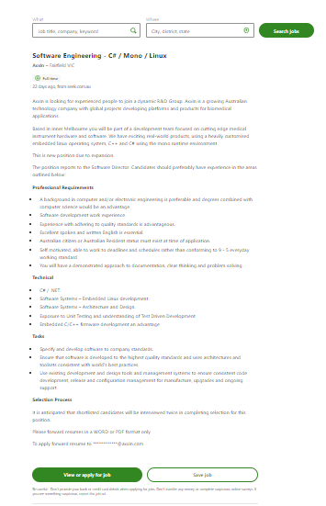

In this job, “Software Engineering - C# / Mono / Linux”, is a company with developing platforms with global projects and products for Biomedical applications. They will be focussing on cutting edge medical and instrumental hardware and software using embedded Linux operating system, C++ and C#.

A Biomedical Software Engineer develops algorithms in order to assist in patient diagnosis and monitoring for e.g., CT scans or MRIs, in which the software has been used to create images from neurological signals and for pacemakers using cardiac signals, which both require complex signal software algorithms. So, Bio medical software engineers design software to run medical equipment and design and build artificial body parts for e.g., hip and knee joints. (<https://l.facebook.com/l.php?u=https%3A%2F%2Fwww.topmastersinhealthcare.com%2Ffaq%2Fwhat-does-a-software-engineer-in-biomedicine-do%2F&h=AT2xc1IAMRDMrEKa87EI3kbrKhuB8urQHcyU6L7tkF6Zfn3KxgZC7VUDgorfmYBjOIA9JLn8iYY-ofEZ2ynAidHOep4H5Q8aeRFPvP4dSOIaXqsmWizldzxyRwUgBKu31GK8EHtF0r64zKY&s=1> )

This job is appealing to me because of my interest in health and being able to help survival of humanity. Having both my parents develop bowel cancer and seeing them suffer is my motivation to be able to use my knowledge in a creative way. I would love to one day be able to assist in creating a new world way of life saving technology. With this job they focus on hardware as well as software which excites me of the possibilities.

**Skills, qualifications & experience required**

For this job application, it requires a background in computer engineering preferably a degree or combined with a computer science degree. They would require software development work experience. Having quality standards, excellently spoken and professionally written English. Either Australian citizens or resident is a must. Needs to be self-motivated and working to schedules and deadlines with clear thinking and problem-solving skills.

The technical skills required would be programming languages, C#/.NET., Embedded C/C++ firmware development, software systems- Embedded Linux development & Architecture and design and exposure to Unit Testing and understanding of Test-Driven Development.

Some experience and qualifications I have are, I have completed my VCE and certificate 3 in hair and beauty including facials and piercing. I have now been doing hairdressing for 14 years. For the past 12 years my husband has been a systems engineer, and in this time, he has passed on some of his knowledge to me. I can perform basic tasks and operate a PC or laptop etc. I have created a website using WIX. I am a highly creative person and in my spare time tend to paint portraits of family members. In high school and I replicated the Starry Night from Vincent Van Gogh. (<https://en.wikipedia.org/wiki/The_Starry_Night>) Being a hairdresser for 14 years has helped me gain confidence in communicating with strangers, making new friends and being out of my comfort zone. Being a senior colourist and stylist, we use maths and science to create formulas and follow procedures and need incredibly good organisational skills. I had a lot of responsibilities in the salon, working under pressure, delegating work to apprentices, time management between clients, organising the product stock, opening and closing the salon, including calculating the earning for the day. I am proud to say my boss had a lot of trust in me.

For me to be successful as a biomedical software engineer after completing my introduction to technology, I would need to obtain a computer engineering degree or even a computer science degree such as Bachelor of Engineering (computer and Networking Engineering) (honours) /Bachelor of Computer Science at RMIT. I would need to start a pathway with a Bachelor of Engineering (computer network engineering)(honours) ([https://pathways.rmit.edu.au/pathway/bh072ad026PATH3comp?_gl=1*hzov1q*_gcl_aw*R0NMLjE2MTU3Njc4NDAuQ2p3S0NBaUFoYmVDQmhCY0Vpd0FrdjJjWTAwRDJvUVFyaUduZWNCNW8ySzFVZmd5RDNNbTVMb09kcmZnVUZVQVdXQTZmeVM4NDAwT3l4b0N2V0lRQXZEX0J3RQ..*_gcl_dc*R0NMLjE2MTU3Njc4NDAuQ2p3S0NBaUFoYmVDQmhCY0Vpd0FrdjJjWTAwRDJvUVFyaUduZWNCNW8ySzFVZmd5RDNNbTVMb09kcmZnVUZVQVdXQTZmeVM4NDAwT3l4b0N2V0lRQXZEX0J3RQ](https://pathways.rmit.edu.au/pathway/bh072ad026PATH3comp?_gl=1*hzov1q*_gcl_aw*R0NMLjE2MTU3Njc4NDAuQ2p3S0NBaUFoYmVDQmhCY0Vpd0FrdjJjWTAwRDJvUVFyaUduZWNCNW8ySzFVZmd5RDNNbTVMb09kcmZnVUZVQVdXQTZmeVM4NDAwT3l4b0N2V0lRQXZEX0J3RQ..*_gcl_dc*R0NMLjE2MTU3Njc4NDAuQ2p3S0NBaUFoYmVDQmhCY0Vpd0FrdjJjWTAwRDJvUVFyaUduZWNCNW8ySzFVZmd5RDNNbTVMb09kcmZnVUZVQVdXQTZmeVM4NDAwT3l4b0N2V0lRQXZEX0J3RQ).. ) then possibly I could move on to Bachelor of computer science. I would need some experience working with software development. I would need to learn some Programming languages including C#/.NET. Embedded C/C++ firmware development, embedded Linux development and architecture and design. I would have to have some work experience in unit-testing and understanding of test-driven development. Ideally, I would like to study as Bachelor of Engineering (computer and Networking Engineering) (honours) /Bachelor of Computer Science at RMIT. ( <https://www.rmit.edu.au/study-with-us/levels-of-study/undergraduate-study/honours-degrees/bachelor-of-engineering-computer-and-network-engineering-honoursbachelor-of-computer-science-bh091/bh091cnhddauscy> )I believe I already have high standards and being self-motivated is already an advantage. I like working to schedules and enjoy problem solving.

**Personal Profile**

The first personality test I used was 16 personalities. These results were that I’m a protagonist - ENFJ-T ( <https://www.16personalities.com/profiles/f33a78bb4a9b1> ) this shows me that I am extroverted and eager to work in teams, I am enthusiastic, influential, genuine, I am success-driven, perfectionistic eager to improve. Also comparing ourselves to others can sometimes create an uneasy feeling of regret. But I can admit I am learning not to compare and instead feel genuine happiness because I do not like that feeling of regret. I do agree with these statements, though, I am surprised that the result show that I am an extroverted leader. I find that over time I have become this type of person willingly but not born with these traits. As a child I was incredibly shy and doing hairdressing has made me grow as a person. Also being a mother to three strong girls has made me become more resilient and has helped form my personality. I guess our life experiences makes us the people we become. Many other specific factors have probably contributed to my personality such as losing my mother as a teenager, my father also getting cancer, I guess what does not kill you makes you stronger. (quoted, the German philosopher, Friedrich Nietzsche.) (<https://l.facebook.com/l.php?u=https%3A%2F%2Fen.m.wikipedia.org%2Fwiki%2FWhat_does_not_kill_me_makes_me_stronger&h=AT17vv0r5zjiww0sDay1d2dGt5x542coPSo4JgAmqFc7MFs6iTuejG1_kKta_G97BcVnSuEvk8vjacasWYR4Bir9zsws1PtnxV1SUx-MX5DmRiTrvaNGZHVwNTShRdelNTfjvbXdiseuMkc&s=1> )

In the personality perfect test shows a similar result, that I’m also an ENFJ-The Giver (<https://www.personalityperfect.com/test/free-personality-test/3te3b572726d0bd33ac2136f55ffd34114e32> ) the results were quite similar with the 16 personality test, surprisingly. It amazed me to see that with these two tests, they have shown such similar personality traits such as, Influential, loyal, reliable, genuinely kind, highly intuitive and reflective, warm, caring, generous, people-focused and a good communicator.

According to the DISC personality test, ( <https://www.truity.com/personality-test/159/result/13094112>) as do the other two previous tests, shows my behavioural style is an influence style. My focus in group work is getting people motivated and working together. Influence styles are being self-confident and upbeat. We are enthusiastic collaborators and love to bring people together. I do agree with these statements, I try and be the best version of myself and I am proud to be me. I love being around groups of family and friends as it energises me.

Although I am happy with my overall personality test results, after completing the three personality tests I believe they show a similar result which indicate to me they are quite accurate in determining my personality traits. When working in teams we should probably look for different types of personalities to balance each other out, although that might mean we are all quite different and might clash, which would potentially create conflict, so maybe grouping up with similar personalities could be better as we will have more in common. The character traits that I appreciate are communication, patience and perseverance. I believe with these you will always be on the same level and issues will always be spoken about and not assumed or fought over.

16 Personalities results

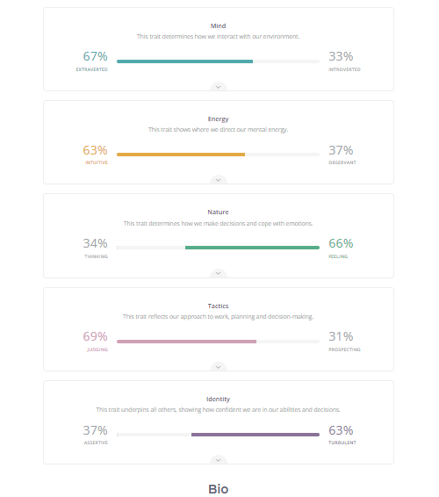

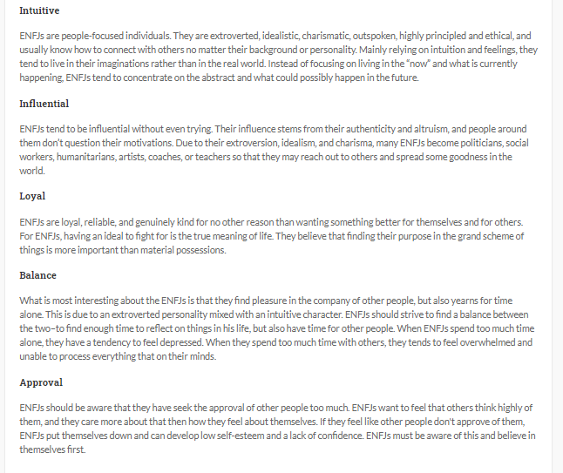

**Project idea**

**Overview**

My project idea is creating an application or programme that you can download on to your device that will be used online or with images saved to your photo album. It would be used in conjunction with online shopping for clothing and accessories. The application will help you decide whether to purchase an item of clothing or accessory by seeing it virtually on yourself. It will be simple to use and by supplying a detailed profile with accurate measurements, you will be able to see the prospected item of clothing or accessory on yourself virtually, before deciding to make the purchase. This app could also be used with existing clothes you already have, to organise potential future outfits or just simply to see if your outfit will match. I aim to create this app to be used by anyone without any tech experience just like you would any other app. It will be consumer friendly and very secure and be assured your data is protected. Having the convenience to virtually try on selected clothes and accessories would be a game changer in the online shopping world.

**Motivation**

Myself, like most other females and males, do online shopping (<https://optinmonster.com/online-shopping-statistics/> ) and sometimes make the wrong decision when making an online purchase, may it be because the item does not suit me because it looked better on the model or because I was not sure which size to get, so I would buy the wrong size, either being too big or too small. This application should help take the stress out of regretful online purchases by eliminating the unknowns and creating more of an expected result. I believe the app will make online shopping easier and more enjoyable for the consumer. It will give you a virtual feeling of shopping without the hassle that regular retail shopping entails such as having to drive and find parking, having to try on garments and undress multiple times and wait in que to be served. Also, if people have young children this task can serve to be impossible, so, usually online is the best solution, it is in the comfort, and safety of your own home.

**Description**

My idea of this application will work quite simply, you will be required to take a clear photo of yourself in modest undergarments and add all required measurements in the profile such as height, weight, BMI (body mass index)- which can be calculated,( <https://www.diabetes.ca/managing-my-diabetes/tools---resources/body-mass-index-(bmi)-calculator#:~:text=Body%20Mass%20Index%20is%20a,most%20adults%2018%2D65%20years>. ) bust, waist and hips measurements.( There could possibly be an option of just a photo of your face if you would prefer, and then in conjunction with your specified body measurements there would be an avatar created as your body type). As you select to go onto your chosen online shopping site, you will find a button linking the app to the selected online store which will redirect you out of the app. You will be advised to save the image or take a snapshot of the selected garment and with the technology in the app it will automatically cut around the perimeter of the garment and apply it to your profile picture. You will then be able to see the chosen garment in your selected size, in conjunction with the specified sizing of the garment, on the website and stretch elements put into consideration. Then, the garment will be applied to your virtual self and here you will be able to determine whether you are satisfied to then purchase the item of clothing or accessory. Try before you buy as people say. I believe this is a great theory and deter you leaving the comfort of your own home. Hopefully, you will not be surprised with any regretful purchases. The app will also be utilized with your existing clothing, the only difference here would be that the garment will need to be photographed flat on a blank background, so the app can acknowledge it.

**Tools and Technologies**

The tools and technologies to create this project idea would require software development, software design, database development using SDK (software developmental kits) and API (application programming interface) ( <https://www.quora.com/How-does-an-API-work-with-a-database> ) in which it will be more personalised and also using SPC (software processing control) which will allow the input of personal data. <https://www.definitions.net/definition/data+processing+system#:~:text=The%20software%20data%20processing%20system,of%20other%20information%20processing%20subsystems>. )

Ideally the app would be a Native app to create a better UX (User Experience) with quick navigation and enhancing the security of the user’s data. (<https://www.upwork.com/resources/native-hybrid-web-app-differences?vt_cmp=11384804789&vt_adg=113089129402&vt_src=google&vt_kw=&vt_device=c&utm_source=google&utm_campaign=11384804789&utm_medium=paidsearch&gclid=Cj0KCQjw0caCBhCIARIsAGAfuMwbSsx2jvZPeZ36kp85MpJuDiB6HaRQkn4tPAmVPVD4SweoW4hywcQaAtDSEALw_wcB> ) Also another advantage of using a native apps is, the camera will be accessed, which is one of the main functions in using the app also being able to interact with the devices operating system with GUI (graphical user interface) (<https://www.omnisci.com/technical-glossary/graphical-user-interface> ). and CLI (command line interface) when inputting the user’s specific measurements. (<https://en.wikipedia.org/wiki/Command-line_interface> ) You would need an Apple mac to work on for the iOS version and usually Windows for the Android version. An iPhone and Android phone will also be needed to test the app on after it is created. You can download XCode, which is open source to develop Apple iOS apps, (<https://developer.apple.com/library/archive/referencelibrary/GettingStarted/DevelopiOSAppsSwift/BuildABasicUI.html> ) and Android Studio for Android apps, (<https://developer.android.com/studio/intro> ) which can be created on Windows devices. A database which will store all the users details including their measurements, profile picture and garments selected, will also be required within the app, this will require SDK and API. The app will be required to allow access to the photo album on the device or you can take a photo with access to your camera. You will also be able to access links to specific shopping websites directly from the app (<https://www.elegantmedia.com.au/blog/everything-need-know-app-links-mobile-app-equivalent-website-urls/> ) using Universal Resource Identifiers (URI) and enable app links which are open source too.

**Skills required**

The skills that this app would require are software programming language using Java Script for an Android app and Swift coding language for Apple apps. In order to create an Apple iOS app, you can use any Mac device and install the XCode programme which uses the swift coding language, making sure you are using the latest updated version of your Mac OS software before starting. There are templates in the app you can use. Here is where the app is designed, the UI (user interface) in the storyboard section. You will need images to use, which you can find free icons in the Icon Store (<https://iconstore.co/> )to add to your app’s GUI, this way preventing copy writing if you do not have originals. (<https://www.youtube.com/watch?v=bUQz9ZWjsvc> ) If you want to make them from on your own, you can use Photoshop, Illustrator and Sketch. (<https://99designs.com.au/blog/web-digital/how-to-design-app-icons/> )

**Outcome**

I predict my app idea could become a big hit especially for women around the world. There have been numerous times when iv been shopping online and I have been so indecisive on whether to purchase the item or not, and usually do, but then regret it. In some cases, I have returned or exchanged the item, but in other cases I have found it too hard and time consuming to then go through the process of returns or exchange, so I am left with the unwanted garment hanging in my closet, collecting dust. I believe this app could revolutionise the online shopping world and the way we know it today. It could even save you time getting ready in the mornings as you have the option of pre organising outfit options with your existing clothes. Therefore, if this app is successful, it will create a new way of shopping that will not only save time but also money from unsuccessful purchases. By being able to see your prospected purchase virtually on yourself would potentially prevent the stress caused by unwanted purchases and help you spend your time the way you choose.

**REFERENCES**

**16 personalities test**

<https://www.16personalities.com/profiles/f33a78bb4a9b1>

**Android apps using Android Studio**

<https://developer.android.com/studio/intro> )

**Angela Yu**

<https://www.youtube.com/watch?v=bUQz9ZWjsvc> )

**App icons**

(<https://99designs.com.au/blog/web-digital/how-to-design-app-icons/> )

**App development software**

( <https://www.goodfirms.co/blog/best-free-and-open-source-app-development-software-solutions> )

**Barbies dreamhouse episodes**

**(**[**https://www.google.com/search?rlz=1C1GCEA_enAU853AU853&sxsrf=ALeKk02iJoBsxEWmQDV3FM1Up-9LZXDoLg:1616054203641&q=barbie+dreamhouse+adventures+season+1+episode+1&stick=H4sIAAAAAAAAAONgFuLVT9c3NExPs8ioqEqzUIJw00zLDMzSjHK1pLKTrfRLyoAovqAoP70oMdcqtSCzOD8ltfgR4ypGboGXP-4JSy1gnLTm5DXGmYxceNQL6XGxueaVZJZUCqlwCUqh2qvBIMXPheYUZyOTXZemnWPTE5Ra9f9_Y1-Ig5Iipw2v_oFPp1_ZC1pX_bsf-MzCQYJFgUGDwfCRJavD-imMB7QYDjAyNe1bcYiNhYNRgMGKSYOpiomDiWcRq35SYlFSZqpCSlFqYm5GfmlxqkJiSllqXklpUWqxQnFqYnF-noKhAtS5CoYAulJYnRwBAAA&sa=X&ved=2ahUKEwizqPuFr7nvAhXO8HMBHfQuDKQQri4wXHoFCAEQlQE**](https://www.google.com/search?rlz=1C1GCEA_enAU853AU853&sxsrf=ALeKk02iJoBsxEWmQDV3FM1Up-9LZXDoLg:1616054203641&q=barbie+dreamhouse+adventures+season+1+episode+1&stick=H4sIAAAAAAAAAONgFuLVT9c3NExPs8ioqEqzUIJw00zLDMzSjHK1pLKTrfRLyoAovqAoP70oMdcqtSCzOD8ltfgR4ypGboGXP-4JSy1gnLTm5DXGmYxceNQL6XGxueaVZJZUCqlwCUqh2qvBIMXPheYUZyOTXZemnWPTE5Ra9f9_Y1-Ig5Iipw2v_oFPp1_ZC1pX_bsf-MzCQYJFgUGDwfCRJavD-imMB7QYDjAyNe1bcYiNhYNRgMGKSYOpiomDiWcRq35SYlFSZqpCSlFqYm5GfmlxqkJiSllqXklpUWqxQnFqYnF-noKhAtS5CoYAulJYnRwBAAA&sa=X&ved=2ahUKEwizqPuFr7nvAhXO8HMBHfQuDKQQri4wXHoFCAEQlQE) **)**

**BMI calculations**

(<https://www.diabetes.ca/managing-my-diabetes/tools---resources/body-mass-index-(bmi)-calculator#:~:text=Body%20Mass%20Index%20is%20a,most%20adults%2018%2D65%20years>. )

**Command line interface CLI**

<https://en.wikipedia.org/wiki/Command-line_interface> )

**Disc personality test**

<https://www.truity.com/personality-test/159/result/13094112>

**First iPhone released**

**(**[**https://www.computerworld.com/article/2604020/the-evolution-of-apples-iphone.html**](https://www.computerworld.com/article/2604020/the-evolution-of-apples-iphone.html)**)**

**GUI graphical user interface**

<https://www.omnisci.com/technical-glossary/graphical-user-interface> )

**Hybrid or Native**

(<https://www.upwork.com/resources/native-hybrid-web-app-differences?vt_cmp=11384804789&vt_adg=113089129402&vt_src=google&vt_kw=&vt_device=c&utm_source=google&utm_campaign=11384804789&utm_medium=paidsearch&gclid=Cj0KCQjw0caCBhCIARIsAGAfuMwbSsx2jvZPeZ36kp85MpJuDiB6HaRQkn4tPAmVPVD4SweoW4hywcQaAtDSEALw_wcB> )

**Icon store**

(<https://iconstore.co/> )

**Information on biomedical software engineer**

<https://l.facebook.com/l.php?u=https%3A%2F%2Fwww.topmastersinhealthcare.com%2Ffaq%2Fwhat-does-a-software-engineer-in-biomedicine-do%2F&h=AT2xc1IAMRDMrEKa87EI3kbrKhuB8urQHcyU6L7tkF6Zfn3KxgZC7VUDgorfmYBjOIA9JLn8iYY-ofEZ2ynAidHOep4H5Q8aeRFPvP4dSOIaXqsmWizldzxyRwUgBKu31GK8EHtF0r64zKY&s=1>

**Invention of tv**

<https://www.wikiwand.com/en/History_of_television>

**Linking website to app**

( <https://www.elegantmedia.com.au/blog/everything-need-know-app-links-mobile-app-equivalent-website-urls/> )

**Native performance**

<https://clearbridgemobile.com/benefits-of-native-mobile-app-development/\>

**Netflix and YouTube on our remotes**

**(**[**https://www.theverge.com/circuitbreaker/2020/4/24/21232655/netflix-button-tv-remotes-advertisement-marketing-streaming**](https://www.theverge.com/circuitbreaker/2020/4/24/21232655/netflix-button-tv-remotes-advertisement-marketing-streaming) **)**

**Nintendo Wii**

**(**[**https://www.britannica.com/topic/Nintendo-Wii**](https://www.britannica.com/topic/Nintendo-Wii) **)**

**Online shopping statistics**

<https://optinmonster.com/online-shopping-statistics/> )

**Personality perfect**

(<https://www.personalityperfect.com/test/free-personality-test/3te3b572726d0bd33ac2136f55ffd34114e32>

**Reference software engineer assisting bio medical technology.**

( <https://www.topmastersinhealthcare.com/faq/what-does-a-software-engineer-in-biomedicine-do/>)

**RMIT courses**

<https://www.rmit.edu.au/study-with-us/levels-of-study/undergraduate-study/honours-degrees/bachelor-of-engineering-computer-and-network-engineering-honoursbachelor-of-computer-science-bh091/bh091cnhddauscy>

[https://pathways.rmit.edu.au/pathway/bh072ad026PATH3comp?_gl=1*hzov1q*_gcl_aw*R0NMLjE2MTU3Njc4NDAuQ2p3S0NBaUFoYmVDQmhCY0Vpd0FrdjJjWTAwRDJvUVFyaUduZWNCNW8ySzFVZmd5RDNNbTVMb09kcmZnVUZVQVdXQTZmeVM4NDAwT3l4b0N2V0lRQXZEX0J3RQ..*_gcl_dc*R0NMLjE2MTU3Njc4NDAuQ2p3S0NBaUFoYmVDQmhCY0Vpd0FrdjJjWTAwRDJvUVFyaUduZWNCNW8ySzFVZmd5RDNNbTVMb09kcmZnVUZVQVdXQTZmeVM4NDAwT3l4b0N2V0lRQXZEX0J3RQ](https://pathways.rmit.edu.au/pathway/bh072ad026PATH3comp?_gl=1*hzov1q*_gcl_aw*R0NMLjE2MTU3Njc4NDAuQ2p3S0NBaUFoYmVDQmhCY0Vpd0FrdjJjWTAwRDJvUVFyaUduZWNCNW8ySzFVZmd5RDNNbTVMb09kcmZnVUZVQVdXQTZmeVM4NDAwT3l4b0N2V0lRQXZEX0J3RQ..*_gcl_dc*R0NMLjE2MTU3Njc4NDAuQ2p3S0NBaUFoYmVDQmhCY0Vpd0FrdjJjWTAwRDJvUVFyaUduZWNCNW8ySzFVZmd5RDNNbTVMb09kcmZnVUZVQVdXQTZmeVM4NDAwT3l4b0N2V0lRQXZEX0J3RQ)..

**SDK and API**

<https://nordicapis.com/what-is-the-difference-between-an-api-and-an-sdk/>

( <https://www.quora.com/How-does-an-API-work-with-a-database> )

**Software process system**

<https://www.definitions.net/definition/data+processing+system#:~:text=The%20software%20data%20processing%20system,of%20other%20information%20processing%20subsystems>. )

**Vincent Van Gogh starry night**

<https://en.wikipedia.org/wiki/The_Starry_Night>

**What doesn’t kill you makes you stronger quote**

(<https://l.facebook.com/l.php?u=https%3A%2F%2Fen.m.wikipedia.org%2Fwiki%2FWhat_does_not_kill_me_makes_me_stronger&h=AT17vv0r5zjiww0sDay1d2dGt5x542coPSo4JgAmqFc7MFs6iTuejG1_kKta_G97BcVnSuEvk8vjacasWYR4Bir9zsws1PtnxV1SUx-MX5DmRiTrvaNGZHVwNTShRdelNTfjvbXdiseuMkc&s=1> )